ACSL
American Computer Science League
2013-2014

Contest #4

Classroom Division Solutions

6. 4

6. Data Structures
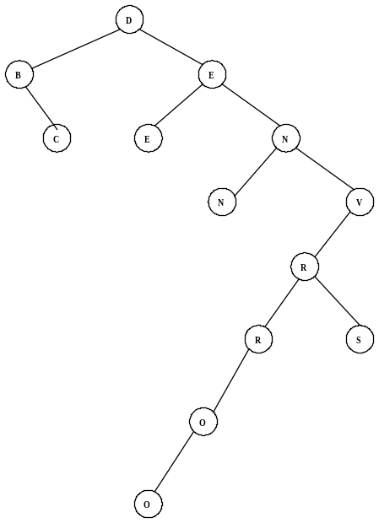

The binary search tree is shown on the right. The nodes with only one child are:
B, V, R, and O.

7. Data Structures
The queue is constructed as follows:
P, PI, PIK, IK, K, KE, KES, KESP, ESP, ESPE, SPE, PE,
PEA, PEAK. The next popped item is P since stacks are FIFO.
7. P

8. Digital Electronics
The circuit translates to: 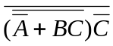
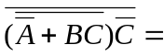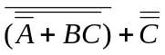=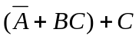= 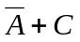
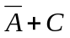= 0 →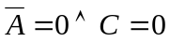Therefore (1, *, 0) makes it FALSE.

8 . (1, *, 0)

9. 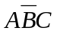
9. Digital Electronics
The circuit translates to: 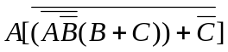
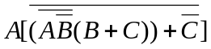=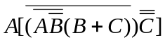=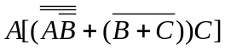
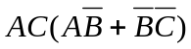=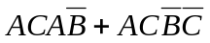=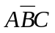

10. LISP
(CAR (CDR (CDR ‘( 1 ( 2 ) ( 3 ( 4 ) ) ) ) ) )
= (CAR (CDR ‘( ( 2 ) ( 3 ( 4 ) ) ) ) )
= (CAR ‘( ( 3 ( 4 ) ) ) )
= ( 3 ( 4 ) )

10. (3 ( 4 ))

